Service Delivery and Operations
Customer Experience Survey
2014/15

Branch Development and Support
Service Delivery and Operations
January 2016

Acknowledgements

The Department of Internal Affairs acknowledges Mark Johnson and his team at Research New Zealand for their analysis of the data.

Author: Thida Seng -Advisor- Branch Development and Support
Introduction

This report provides a summary of key findings from the 2014/15 Service Delivery and Operations Customer Experience Survey.

Service Delivery and Operations (SDO) provides a variety of services to the public including passports, community development advice and grants, birth, death, marriage, civil union, and name change, citizenship, charities registration, and identity verification services.

In this survey we seek to understand how the public rates our service, how they interact with SDO and what we can do to improve our service.

The 2014/15 survey is the third in a series of annual surveys to monitor public satisfaction over time, and to monitor responses to changes in our service delivery.

Key Findings

- Overall, Service Delivery and Operations customer satisfaction with the services the Department of Internal Affairs deliver remains high.

- Overall SDO customers reported that it was easy to do business with Service Delivery and Operations.

- However improvements or additions to online services remain a key customer need.

- Customers continue to have high expectations of the service they expect to receive and rated the service they actually received as better than expected.

- Interactions with SDO staff remain highly rated.

- Customers of SDO continue to have high trust and confidence in the Department of Internal Affairs.

Overall Satisfaction

Most customers (90 per cent) were satisfied or very satisfied with the overall quality of SDO service delivery. Results in 2014/15 were basically the same as in 2013/14, reflecting the maintenance of a high level of service.

Source: Service Delivery and Operations Customer Experience Survey 2012/13, 2013/14 and 2014/15

Examples of very positive feedback provided by customers:
I wasn't expecting the application would be so easy as I am now living overseas. They replied to my email on spot and the officer called me to confirm my information the same day they received the application form. She was very professional and friendly, I was overwhelmed. The whole process only took one day to complete. The best experience I have had - thank you.
I have been doing this for twenty years, starting with applying on paper and then going online. The service has improved year by year and it is now a good service. The staff have always been polite.

Everything was done face to face and she explained everything and especially taking into [account] the fact that I wasn't a New Zealander. They were very good [at] taking in cultural customs.

I needed my certificate urgently and being a Friday I didn't expect it until Monday and it turned up on Saturday. The guy I spoke to was amazing.

I needed to upgrade to an emergency passport as my grandmother died before I got my passport. I rang the department and they were amazing! Made everything so painless and I had my passport in a matter of hours.

Honestly I have never ever been so happy with a service. Especially in London. Very quick, reliable, friendly and just perfect, you were informed about every step. Well done.
Service Expectations and Experience

Half of SDO customers had high expectations of the quality of service they would receive and felt that the resulting service received was better than expected.

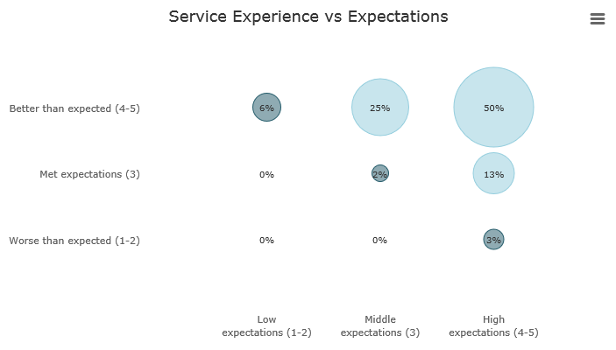
Source: Service Delivery and Operations Customer Experience Survey 2014/15

Key Service Measures

SDO customers rated the key service measures highly. In particular “Staff were competent”, “Staff did what they said they would do”, and “I was treated fairly” were all rated above 90 per cent. These three measures relate directly to service received from SDO staff.

Note: Only SDO customers who had had direct contact with an SDO representative were asked whether Staff were competent, Staff did what they said they would do, or I was treated fairly.
Source: Service Delivery and Operations Customer Experience Survey 2014/15
Trust and Confidence

SDO customers continued to report high trust and confidence in the Department of Internal Affairs.
Slightly lower results for Charities Services reflect the regulatory nature of the business.

Source: Service Delivery and Operations Customer Experience Survey 2014/15

Ease of doing business with SDO

Overall 86 per cent of SDO customers reported that it was easy to do business with Service Delivery and Operations. Slightly lower results for Charities Services reflect frustrations customers have with the website and online service.
International research shows that ease of doing business, and what you do to enable that, are key drivers to assess how well we are performing and provide us with actionable next steps to improve the customer experience.

Source: Service Delivery and Operations Customer Experience Survey 2014/15
Service Improvements

About half of SDO customers felt that SDO could make improvements to our service. Among those who made suggestions, the biggest group was once again those who suggested improving our website and online service.

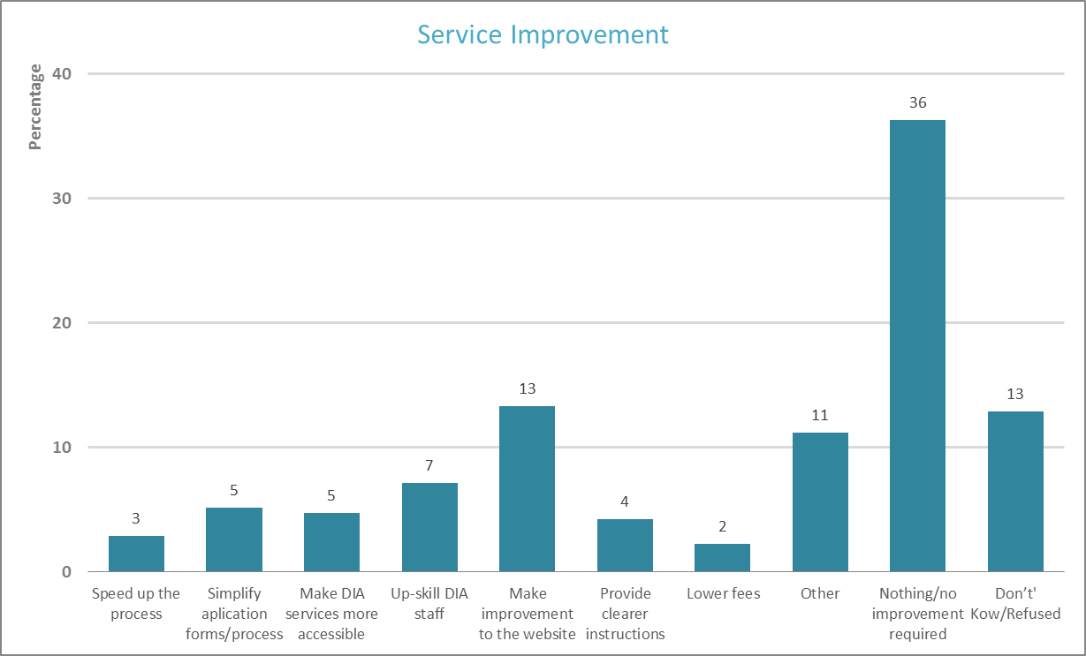
Source: Service Delivery and Operations Customer Experience Survey 2014/15

Examples of the types of comments received from customers regarding improvement are:

Make the application form very clear in respect to supporting documents. i.e. marriage certificates and passports of applicants (including babies).

Correct the face dimension guideline for the photo, so that we don't waste time trying to make it and meet the dimensions, when it is accepted outside of these dimensions.

Improve the instructions, so it's easier for people to read, or like watching a video to understand, especially for language barriers.

Provide an online tracking service so that you can view the progress of an application.

Simplify the application for those who apply regularly. It shouldn't be necessary to repeat pages of information that you gave them last year and should be still in their system.

They are very helpful, but I belong to a group of elderly people, and some of us are not very good on computers, and their forms are all on computer, and aren't posted out anymore.

They need to redo the Auckland office. It's quite tacky and doesn't show New Zealand off in a good light.

Design application and accountability requirements as simply as possible, and from the perspective of applicants of all IT skill levels.

Instead of posting mail, use email or phone first [and] then post. Some people want it as soon as possible.

Next Steps

SDO is working to transform our system of service delivery. Findings from this research will help us understand our customers’ needs and enable us to see the effect of service changes on our customers.

Improving our web and digital services is a strong focus for SDO. Analysis from the survey, particularly of customer comments, will help direct this.

One example of this improvement is the organising of Births, Deaths and Marriages information on govt.nz on a customer-need basis so that information about registering a birth is included with other related content on pregnancy and giving birth. This makes it easier for customers to find the information they need.

The SDO Customer Experience Survey is being run again in 2015/16 with results expected to be published late 2016.

Methodology

The 2014/15 survey was run continuously during 2014/15. Recent customers were asked to participate via a telephone or online survey. 2,800 customers completed the survey. The margin of error is between +/-3.8% and +/-4.6% for each business group.

All changes between years are not statistically significant, therefore we cannot say for certain that there has been any change.
All changes between years are not statistically significant, therefore we cannot say for certain that there has been any change.
Source: CEB Customer Contact Council Member Survey 2010

