Service Delivery and Operations
Customer Experience Survey
2012-13

Branch Development and Support
Service Delivery and Operations
January 2014

Acknowledgements

The Department of Internal Affairs acknowledges Mark Johnson and his team at Research New Zealand for their analysis of the data.

Author: Claire Harkess with assistance from Bruce MacFarlane, Branch Development and Support
Introduction

This report provides a summary of key finding from the 2012/13 Service Delivery and Operations Customer Experience Survey.

Service Delivery and Operations (SDO) provides a variety of services to the public including passports, community development advice and grants, birth, death and marriage registrations, citizenship, charities registration, and identity verification services.

In this survey we seek to understand how the public rates our service, how they interact with SDO and what we can do to improve our service.

The 2012/13 survey is the first in an annual series of surveys to monitor public satisfaction over time, and responses to changes in our service delivery.

Key Findings

- Overall, satisfaction with the service SDO delivers is high. However slightly lower satisfaction with online services is highlighted from feedback on improvements that could be made to our website.

- Many customers had high expectations of the service they would receive and then rated the service they actually received as better than expected.

- Interactions with SDO staff are also highly rated.

- SDO customers have high trust and confidence in the Department of Internal Affairs.

OVERALL SATISFACTION

Overall 90% of customers were satisfied or very satisfied with the overall quality of SDO service delivery. Results for each business group range from 83% satisfied or very satisfied with Charities Services up to 91% for Passports Services.

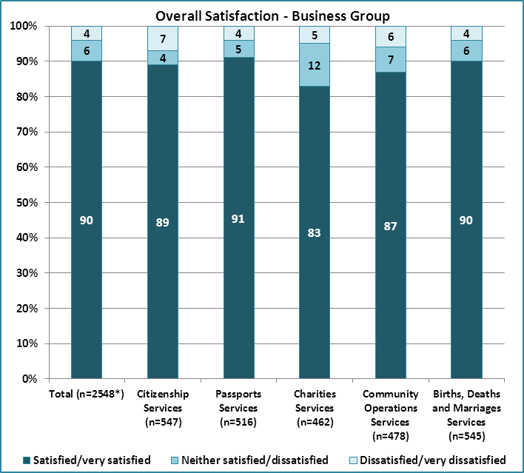
Source: Service Delivery and Operations Customer Experience Survey 2012/13

Examples of the types of comments from customers are:

I received excellent service, I had calls returned promptly and staff were helpful and courteous at all times. Service beyond the call of duty.

Services in our experience have been first class. Any questions raised by our organisation have been promptly dealt with by telephone contact.

The service we received (on a number of occasions) have always been efficient, prompt and professional.

I had a great experience with the DIA. They were very helpful and polite and made the whole process very easy.

Carry on dealing in the same manner as I was dealt with. It left a very good impression which I commented on to my family and friends. They certainly couldn't improve on it because it was top draw.

It was the fastest and most professional service I received from a New Zealand Government department.

Service Expectations and Experience

Just over half of SDO customers had high expectations of the quality of service they would receive by going to SDO and felt that the resulting service received was better than expected.

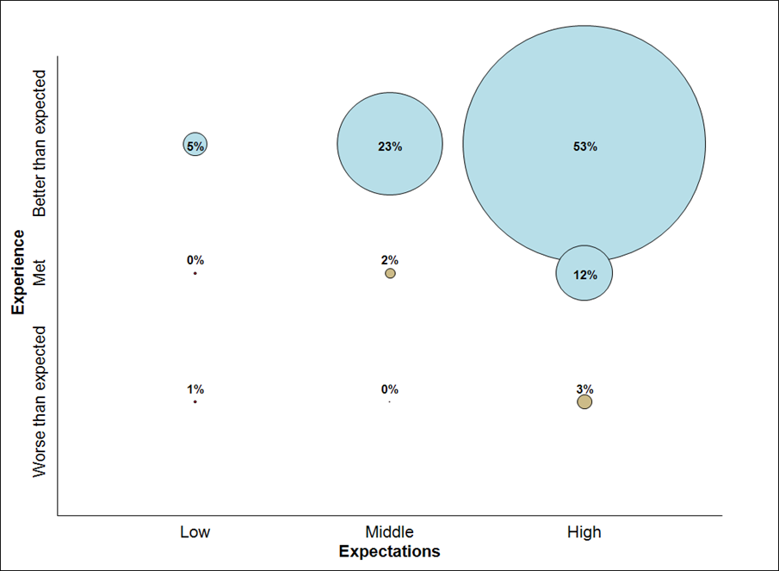
Source: Service Delivery and Operations Customer Experience Survey 2012/13

Key Service Measures

SDO customers rate the key service measures highly. In particular “Staff were competent”, “Staff did what they said they would do”, and “I was treated fairly” were all rated above 90%. These three measures relate directly to service received from SDO representatives.
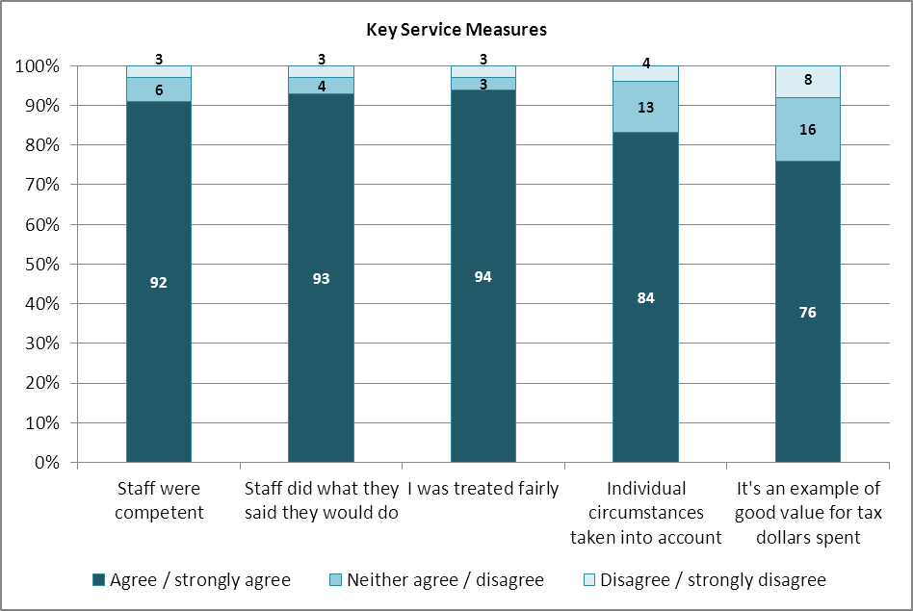
Note: Only SDO customers who had had direct contact with an SDO representative were asked whether Staff were competent, Staff did what they said they would do, or I was treated fairly.
Source: Service Delivery and Operations Customer Experience Survey 2012/13
Service Improvements

Just under half of SDO customers felt that SDO did not need to make any improvements to our service. For those who did make suggestions, the biggest group were in relation to improving our website and online service.

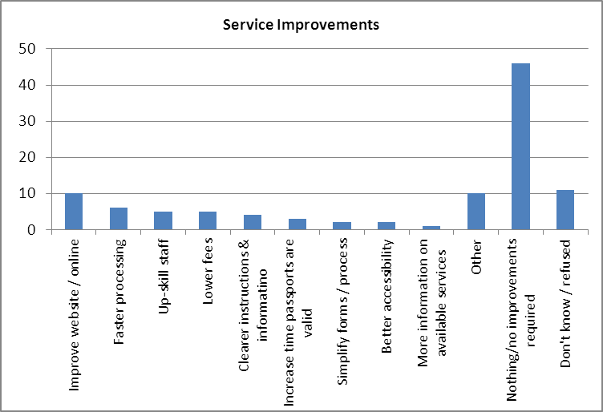
Source: Service Delivery and Operations Customer Experience Survey 2012/13

Examples of the types of comments from customers are :

There was a long delay (6 weeks) between applying and having our case looked at. They did however warn us immediately after accepting the application that we could expect such a delay and their estimate was approximately correct.

They could make filling out the forms a little bit less complicated. It took a lot of effort to go through it and make sure you did the right things.

Better hours, since they're only open a few hours a day during the work week.

Need to be aware of people who are not IT literate, or [have] English as a second language. Website could do with de-cluttering. It is a very governmental website, hard to navigate.

Have a look at their website from more of a non expert non user point of view. We don't know our way around.

I think the most important thing that they could do is the website could be improved so that [it's] more straightforward.

With using the online service it wasn't clear to what was required in away of collateral information.

Trust and Confidence

SDO customers generally report high trust and confidence in the Department of Internal Affairs.

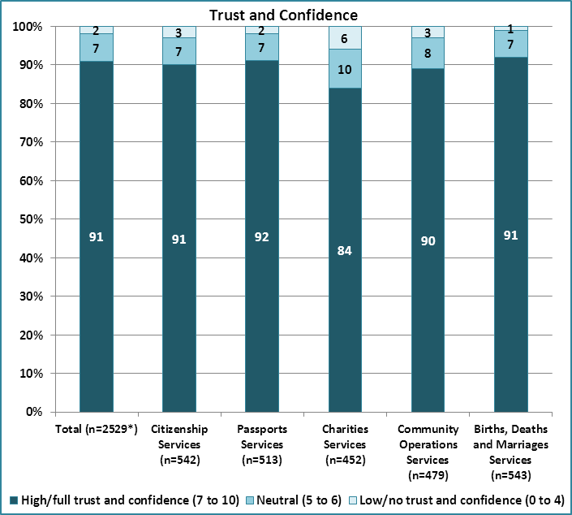
Source: Service Delivery and Operations Customer Experience Survey 2012/13

Next Steps

SDO is working to transform our service delivery. Findings from this research will help us understand our customer’s needs and enable us to see the effect of service changes on our customers.

Improving our web and digital services is a strong focus for SDO.

The SDO Customer Experience Survey is being run again over 2013/14 with results expected to be published late 2014.

Methodology

The 2012/13 survey was run at the end of 2012/13. Recent customers were asked to participate via a telephone or online survey. 2,558 customers completed the survey. The margin of error is between +/-4.0% and +/-4.5% for each business group, with the exception of Charities Services which is +/-2.3%.

